# WEB503 Assessment Three – Project Brief

uShop – Online eCommerce Solution

## 1 - Introduction

### 1.1 - Company Background

uShop is an eCommerce start-up, aiming to gain a foothold in the online marketplace. It has no pre-established history or established userbase, but aims to build a strong online following.

### 1.2 - Product Proposition

uShop aims to provide a wide range of products across many fields. The products listed are mainly non-specialised, utility-based items, which aim to fulfil the basic functional needs of customers.

### 1.3 - Value Proposition

uShop plans to provide a dynamic and responsive service to online customers, creating a truly unique shopping experience. It will differentiate itself not on quality of products offered, but on competitive pricing and a revolutionary user experience.

### 1.4 - Product benefits

uShop’s products will cater to everyone, helping to improve and enhance the basic tasks that occur throughout user’s lives.

## 2 - Product Details

The site should provide an excellent service to customers via a streamlined shopping experience. Customers should be able to navigate swiftly to a desired location and painlessly interface with the payment system. They should takeaway a feeling of satisfaction associated with the site.

In order of importance, the site should emphasise:

* A straightforward and to-the-point interface.
* Painless navigation
* Forms undemanding of personal user information
* A broad catalogue of desirable items

## 3 - Goals and Objectives

uShop aims to provide an online shopping experience that feels as smooth as possible. Users should feel safe, secure, and assured about their purchase decisions.

Envisioning the average customer walkthrough of the website, we want them to feel streamlined through the process, not held back by technical or visual disturbances:

* Account creation should be simple and non-intrusive. Payment or shipping details should not be required until the order processing stage.
* Browsing the store catalogue should be informative but concise, most users already know what they are looking for when shopping online, and so product cards should only display critical information such as price, rating, name, and an image. Further detail can be provided later, after users show specific interest.
* Ordering products should be straightforward. Details of included items and total cost should be clearly visible so users know exactly what they are getting.

## 4 - Wireframes

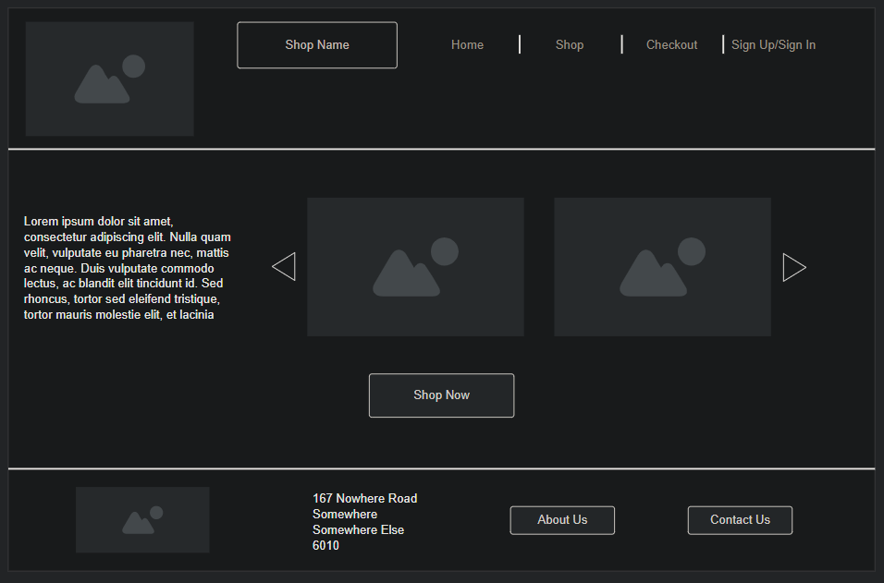

*4.1. – Home Page*

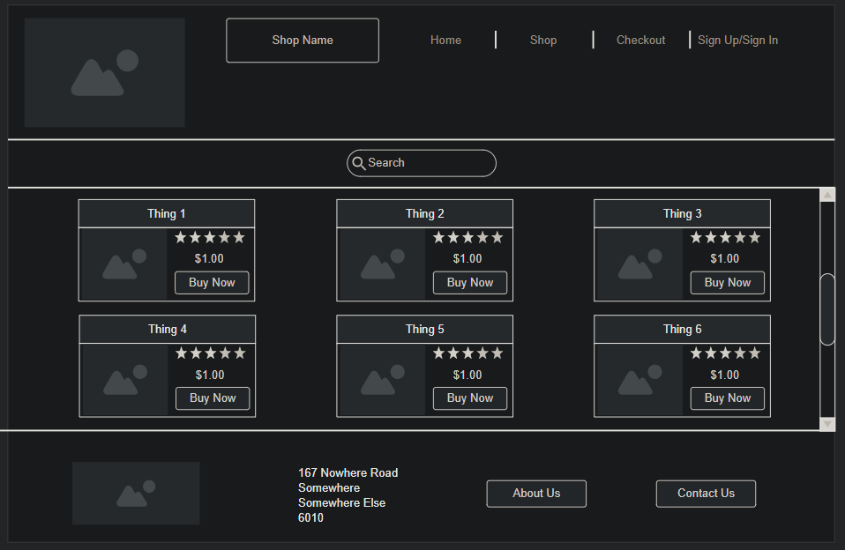

*4.2. – Shop*

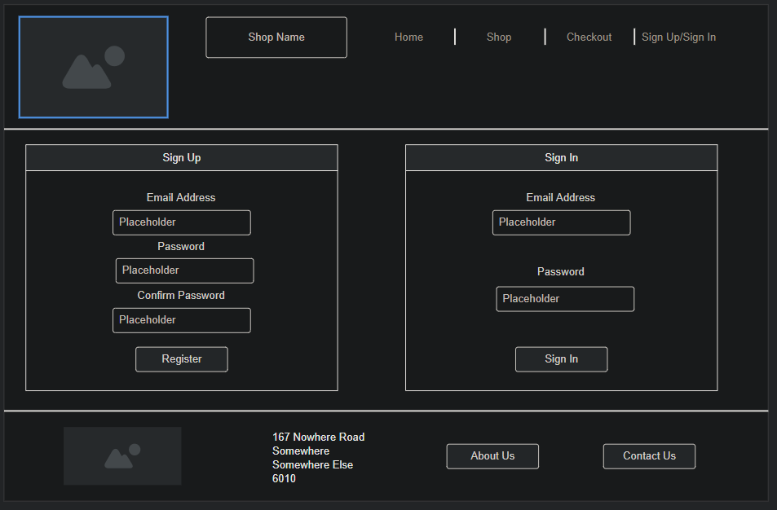

*4.3. Log In/Sign Up*

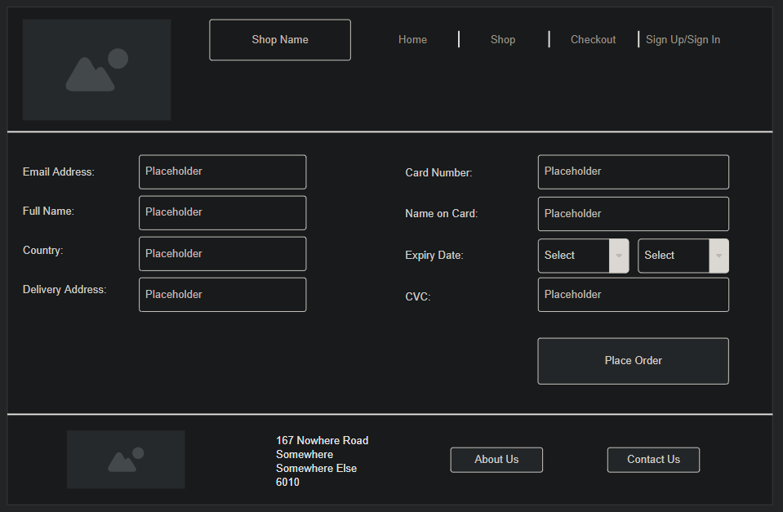

*4.4. – Checkout*

## 5 - Key Areas

### 5.1 - Major Competitors

The online marketplace is a highly competitive environment, featuring many large and well-established retailers. Even discounting international super-powers such as Amazon, New Zealand has many large online stores such as Mighty Ape, as well as some brick-and-mortar stores expanding into the online space such as The Warehouse and Bunnings. These competitors strengths lie in their broad reach and sizeable catalogues. uShop aims to secure a niche in the market by being accessible and providing a positive user experience.

### 5.2 - Target Audience

This site aims to market to a wide range of individuals, regardless of situation. The biggest turn off for customers would be difficulty throughout the online shopping experience - such as delays, inconsistency, and poor navigation design.

### 5.3 - Project Timeline

This project aims to deliver a functional prototype by the date 22/11/2020, encompassing the features and intent of a final release. This prototype, if acceptable would then be able to be linked to a secure database, hosting, and payment service, and hopefully be ready for deployment in late 2020 to early 2021.

### 5.4 - Project Budget

This project will be worked on internally, requiring no outsourcing of development talent. The costs for deployment, operation and maintenance are determined to be in the range of approximately 50 USD per month, increasing as the site develops and expands in future.

### 5.5 - Web App Functionality

uShop will feature all expected features of a standard eCommerce solution, including:

* Browsable Store
* User Account Creation
* Cart
* Checkout

### 5.6 - SEO/Digital Marketing

uShop lacks any pre-established social media or search engine presence, and so will have to work to achieve a foothold in the online marketplace.

Social media accounts will be established on sites such as Facebook, Twitter, and Instagram, where product release and updates can be announced, discussed, and viewed by customers and the general public.

SEO will be optimized by having good crawl accessibility for search engines, strong and compelling language to entice potential customers, and strong keywords aiming to attract common search queries.

### 5.7 - Contact Information

+64-245-5592-5

ushophelp@ushop.com

167 Nowhere Road

Somewhere Else

6010

## 6 - Conclusions

uShop is an emerging eCommerce store, lacking fundamental strengths such as an existing brand image, or following. In order to succeed, it must reach users in the online space and retain their interest. It must provide a solid and reliable service that differentiates it from its strong competitors and have a product catalogue that is enticing.

## 7 - Recommendations

* Marketing Campaign – In order to reach users, uShop needs to gain a presence on social media, interacting with potential customers and rendering itself as an approachable entity.
* Ongoing Development – To continue to provide a unique experience to customers, uShop must keep up to date with progress in the online marketplace, new features should be added and promoted to stay relevant in the fast-changing world of eCommerce.
* Product Research – If uShop is to have a compelling catalogue of products, it must ensure that each item fulfils a defined and tangible need for its customers. This can be accomplished through active and ongoing research into new and existing products to identify the best candidates for additions to the uShop store.

## 8 - References

Beginner's guide to SEO [Search engine optimization]. (2019, April 1). Moz. <https://moz.com/beginners-guide-to-seo>